

**e-Yantra Robotics Competition - 2018**

**Theme Analysis and Implementation - Nutty Squirrel**

**NS#263**

|  |  |
| --- | --- |
| **Team leader name** | **Brijesh kumar patra** |
| **College** | **National Institute of Science and Technology** |
| **Email** | [**patrabrijesh7@gmail.com**](mailto:Patrabrijesh7@gmail.com) |
| **Date** | **02/01/2019** |

**Scope and Preparing the Arena**

**Q1. State the scope of the theme assigned to you. (5)**

The theme assigned to us is “Nutty Squirrel” which mimics the behavior of Squirrel. This theme consists of a robot and a lift mechanism which carries and places nuts in different spots according to their color. The robot will start from the Start Point and will follow the path provided overcoming the obstacles. The nuts are to be picked from the pickup zones and deposited in in the deposit zones. After the nuts are picked from the pickup zone the bot has to follow the shortest path towards the deposit zone. Our main objective is to use minimum time to pick and place the nuts in their respective places.

In our opinion this theme can be used in:

1.Warehouses and factories where different products are to be sorted and placed in different places

In a minimum amount of time.

2. Road transport using internet to find the shortest path to the destination.

**Q2. Attach the image of final arena that you have prepared. (5)**

< Prepare the arena according to the steps given in *Preparing the Arena* section in Rulebook. Please follow the arena configuration shown in Final Arena of the Rulebook.

Place the Nuts (Red, Blue and Green) in the Pick-up Area and Lift structure in lift section.

Take 3 photos of the completed arena from different angles such that the entire arena is clearly visible in the photos.

The three image files should be uploaded along with this document in zip format.>

**Building Modules**

**Q3. Identify the major components required for designing the robotic system and lift mechanism for the solution of the theme assigned to you. (5)**

Robot:

A. Electronic systems:

1. Servo motors: Two servo motors will be required for the movement of the arm so as to pick and place the nuts

2. Colour sensor: It is used to detect the colour of the nuts

3. Sharp sensor: It is used to detect the obstacles in the path.

5.12V 100rpm DC motors: These are used for the movement of the bot.

6. Arduino mega: It is used to control all the major functions of the bot

7.White line follower IR sensor: This sensor is used detect the path so as to make the bot travel through a specified path in the arena.

B. Mechanical System:

In the robot, mechanical part lies in the arm part where the arm has two servo motors. The purpose of the !st servo motor is to move the arm in X-axis and the 2nd servo motor is used to control the grip of the arm.

Lift Mechanism:

Mechanical System:

1. Channel sliders: In the lift mechanism we have used 4 channel sliders (which are used in drawers). We have set the sliders according to the dimensions provided to us (34cm X 34cm). A wooden platform is attached to the sliders which will move up and down with the help of sliders.

2. A shaft: A shaft having a small bearing attached to it which is used as pulley for lifting purposes. The mechanism is so adjusted such that the system works smoothly.

Electronic System:

1. A 12V motor along with L298N motor driver (that was provided to us) has been used for lifting purposes.

2. IR sensor: It is used to detect the presence of the robot as soon as it reaches inside the lift.

3. Limit switches: Two limit switches one at the top and other at the bottom are used to stop the lift at a required height and at initial position so as to make it automatic.

4. Arduino Nano: It is the brain of lift mechanism which is used to operate the lift according to the input of the IR sensor and limit switches.

**Q4. Can you optimize the given sensors and actuators to perform the tasks. If yes, then how? (5)**

Robot:

A. Electronic systems:

1. Servo motors: Two servo motors will be required for the movement of the arm so as to pick and place the nuts

2. Colour sensor: It is used to detect the colour of the nuts

3. Sharp sensor: It is used to detect the obstacles in the path.

5.12V 100rpm DC motors: These are used for the movement of the bot.

6. Arduino mega: It is used to control all the major functions of the bot

7.White line follower IR sensor: This sensor is used detect the path so as to make the bot travel through a specified path in the arena.

B. Mechanical System:

In the robot, mechanical part lies in the arm part where the arm has two servo motors. The purpose of the !st servo motor is to move the arm in X-axis and the 2nd servo motor is used to control the grip of the arm.

Lift Mechanism:

Mechanical System:

1. Channel sliders: In the lift mechanism we have used 4 channel sliders (which are used in drawers). We have set the sliders according to the dimensions provided to us (34cm X 34cm). A wooden platform is attached to the sliders which will move up and down with the help of sliders.

2. A shaft: A shaft having a small bearing attached to it which is used as pulley for lifting purposes. The mechanism is so adjusted such that the system works smoothly.

Electronic System:

1. A 12V motor along with L298N motor driver (that was provided to us) has been used for lifting purposes.

2. IR sensor: It is used to detect the presence of the robot as soon as it reaches inside the lift.

3. Limit switches: Two limit switches one at the top and other at the bottom are used to stop the lift at a required height and at initial position so as to make it automatic.

4. Arduino Nano: It is the brain of lift mechanism which is used to operate the lift according to the input of the IR sensor and limit switches.

**Actuators**

**Q5. What are the different actuators you are planning to use in the robot and lift mechanism. Justify their use? (5)**

(i)Robot:

1. Two 12V DC motors of 100rpm each will be used for the movement of the bot.

2. Two servo motors will be used for pick and place mechanisms.

(ii)Lift mechanism:

1. 12V DC motor of 60 rpm will be used in lift mechanism.

**Power Management**

**Q6. Explain the power management system required for a robot and lift mechanism in Nutty Squirrel theme implementation. What are the aspects that you should look into for designing the power management? (5)**

1. Robot: In the robot we ae using the lipo battery having a power rating of 2200mAH and voltage rating of 11.1v 2C. Direct power from the battery is provided to the DC motors. And further we are using 7805 to power the Arduino Mega and other components used in the bot such as Sharp Sensor ,Servo motors etc.
2. Lift mechanism: In the lift mechanism we are using a power adaptor of voltage rating 12v and current rating 1A. Direct power from the battery is provided to the DC motors Further we are using 7805 to power the IR sensor and Arduino nano.

**Design Analysis**

**Q7. How are you planning to design the robot to detect the presence of Obstacles, Nuts and Lift structure? (4)**

The robot will consist of line sensor array for detecting the path and follow it. A Sharp Sensor will be placed at the front of the bot to detect any obstacles in the path.

A color sensor will be fixed in the arm of the bot to detect the color of the nuts. After detecting the color the bot will use the arm where there will be 2 servo motors which will make the arm move in X-axis and another for the grip to pick up the nut and traverse to the appropriate deposit zone to place the nut.

For detecting the lift , we will use the node present on the lift which will be detected by the line sensor and then identified by its number in the algorithm. The bot will wait at that node until the lift reaches from bottom to top or from top to bottom. After the bot enters the lift the IR senses an obstacle and the 60RPM motor moves the lift upwards till the limit switch detects the position of the lift. While returning the IR again senses and the motor moves the lift downwards till the limit switch detects the initial position of the bot.

**Q8.Teams have to design a mechanism for picking and placing the Nuts in Deposit zones.**

1. **Choose an option to position the mechanism on the robot and why? (4)**
2. **Front 2. Back 3. Right/Left 4. Other position**

We will place the pick and place mechanism at the front of the bot as according to our algorithm the bot stops at the pickup nodes in a direction facing the nuts. Moreover this placement also helps in balancing the bot so as to counterweight the torque of the 100RPM motors.

1. **Explain the design of the mechanism and how it is mounted on the robot.(4)**

We will be using two servo motors for controlling the movement of arm. One servo will be fixed on the bot which will be used for upward and downward movement of arm in X-axis and other servo will be at the end of arm which will be functioning the grip for grabbing the nuts.

1. **What challenge/s do you expect to face while designing the picking and placing mechanism of the Nuts and how you will overcome them? (2)**

Challenge: As the nut is places 15 cm away from the node present in the path of arena so the placing of colour sensor is a challenge.

Solution: Colour sensor is placed in the front of the arm with the grip so that the colour sensor detects the colour and picks the nuts.

Challenge: Picking the nut and position of servos

Solution: Arm should be able to pick and hold the nut properly so proper grip is made so that the nut is hold properly and never slips.

1. **Explain the design and working of the lift mechanism. (4)**

The lift mechanism consists of a IR sensor for detecting the presence of robot on the lift and two limit switches one at top and one at the bottom for stopping the lift when it reaches appropriate height or the bottom. When the bot reaches the node present on the lift it is detected by the IR sensor on the lift and the lift starts moving upwards. The top limit switch is placed in such a way that it is pressed when the lift reaches the required height and as a result it stops.

Similarly, while going down the bottom limit switch is pressed when the lift reaches the ground level and as a result it stops.

1. **What challenge/s do you expect to face while designing the lift mechanism and how you will overcome them? (2)**

Challenge: Placing all the components within the given dimensions.

Solution: We used the least no. of components possible and utilized maximum of the available space.

Challenge: Weight of the bot

Solution:As we have used 1 motor so all the pressure lies on the opposite side and the lift inclines a bit .so we have used channel sliders and Aluminium bars to support the opposite side .

To decrease the friction we have used bearing which acts as pully and lifts the bot smoothly.

**Testing your knowledge (theme analysis and rulebook-related)**

**Q9. Answer the following questions related to the sensors**

**a. What is the principle of operation for: (i) the color sensor and (ii) Sharp Sensor (iii) IR Sensor? Also, for each sensor mention the threshold value for sensing. (15)**

1. Color Sensor: The color sensor consists of 4 white LEDs and 4 filters i.e. red, green, blue and clear filter. Each filter allows only a specific color light to pass through it. When the white light from LEDs falls on an object it is reflected back by the object. The filters are selected one by one and to measure the intensity value of each primary color present in reflected light and then the intensities are compared to determine the color. Threshold value : 1500.
2. Sharp Sensor: It consists of an IR LED with a lens which emits a beam of Infrared light. After this beam reaches the object it is reflected back and directed through another lens to a position-sensible photo detector. The conductivity of this photo detector varies with the position of falling beam. Then it is converted to distance using ADC.
3. IR Sensor: It consists of a IR LED and a Photodiode. The IR LED emits IR radiation and the photodiode senses it. The resistance of photodiode changes according to amount of radiation falling on it.

**Algorithm Analysis**

**Q10. Draw a flowchart illustrating the algorithm you propose to use for theme implementation. (10)**

< The flowchart should elaborate on every possible function that you will be using for completing all the tasks in the assigned theme.

Follow the standard pictorial representation used to draw the flowchart. >

**Q11. What path planning algorithm you are planning to use and how it is going to affect the theme implementation? (5)**

We have used BFS (Breadth First Search) algorithm for path following. The aim of BFS algorithm is to traverse to the node as close as possible to the root node.

In our theme, first of all we numbered all the nodes and represented the arena as a weighted graph in form of a matrix as follows :- If there is an edge between node ‘i’ and node ‘j’ then graph [ i , j ]= <some weight corresponding to the length of edge > and if there is no edge between node ‘i’ and node ‘j’ then graph[ i , j ] = 0.

All the nodes at pickup zone and deposit zones are stored in separate arrays.

Every time a path is found using BFS it is stored in the path [ ] array.

A variable current_node is used to keep track of current node while traversing the path.

A function ( travel_path ) is defined for traversing the path found by BFS algorithm. In this function we have defined for each node that in which direction and by how many nodes the bot should move to reach the next node in path. The direction is specified based on the previous node and the next node.

In the main theme logic, first using BFS we calculated the path from start node ( node 0 ) to the first node in pickup zone array. Our main objective is to pick the nuts from PICK UP ZONE and place them in their appropriate DEPOSIT ZONES. While traversing the path if any obstacle is found the bot returns to the previous node and again calculates the new path for the destination and this time the edge with the obstacle is not considered i.e. if there is an obstacle between node ‘i’ and node ‘j’ then graph [ i , j ] is made 0.

After reaching a pickup node it checks for the NUT if nut is present then it detects its color and picks it up and according to the color of the nut it goes to the corresponding deposit zone and places the NUT. This is repeated until all NUTs are deposited in the appropriate deposit zones.

Once all the nuts are deposited in the deposit zones the bot returns to the starting position.

While going to or returning from the elevated part of the arena the bot will detect the lift by the node present ( bot can identify the node on which it is by the current_node variable defined earlier) on the lift. Then it waits there until the lift goes up or down and then continues following the path upto its destination.

**Programming**

**Q12. How do you plan to synchronize the actions of robot and lift mechanism? (5)**

The lift mechanism consists of a IR sensor for detecting the presence of robot on the lift and two limit switches one at top and one at the bottom for stopping the lift when it reaches appropriate height or the bottom. When the bot reaches the node present on the lift it is detected by the IR sensor on the lift and the motor starts and lift starts moving upwards, the top limit switch is placed in such a way that it is pressed when the lift reaches the required height and as a result the motor stops.

Similarly, while going returning the IR sensor detects the robot and the motor starts and the lift goes down bottom till the limit switch is pressed when the lift reaches the ground level and as a result the motor stops

..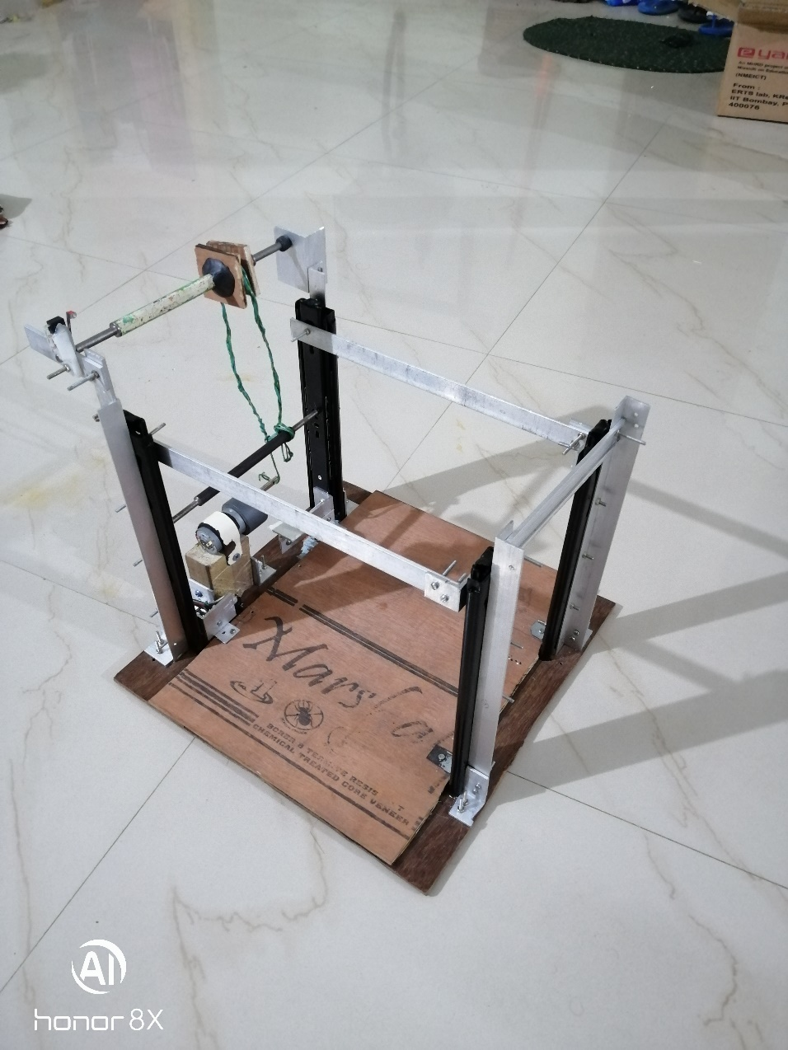

**Challenges**

**Q13. What are the major challenges that you can anticipate in addressing this theme and how do you propose to tackle them? (5)**

1. Challenge 1: Completing the whole run in shortest time possible – to complete the run in shortest time possible we need a optimal path planning algorithm to find the shortest path considering the obstacles present in the path.

2. Challenge 2: Detecting the obstacles accurately – to detect the obstacles we will be using the Sharp sensor which will be placed in the front of the bot.

3. Challenge 3: Picking and placing the nuts at appropriate deposit zones – the arm need to be designed is such a way that it can pick and place the nuts from distance of about 15 cm as the nodes are about 15 cm away from the pickup and deposit zones. It should also be able to properly grab the nuts.

4. Challenge 4: Proper line following – Proper line following and node detection is the most important aspect of this theme. We are planning to use PID for accurate line following.

**Cost Analysis**

**Q14. What is the approximate cost of theme after considering individual component?**

**(You may include flex printing cost as well, list it separately)**

Flex : 1000/-

Aluminium clamps and bars : 250/-

Nuts and bolts : 150/-

Plywood : 300/-

Color Paper Printing and Thermocol : 90/-

Channel Sliders: 400/-

Acrylic Board : 200/-

Shaft and Pulley : 200/-

**Rules and Scoring**

**Q15. Nutty Squirrel theme consists of the following formula for scoring as mentioned in Judging and Scoring section of Rulebook:**

**Total Score = (600-T) + (CD*50) + (CDP*100) – (ID*20) – (IDP*40) + B – P**

**What will be your strategy to earn maximum points in a run? (10)**

Our strategy is to focus on accuracy i.e. correct detection and deposition and minimizing the time taken to complete the run. Also we will try not to incur any penalties.